EZ Tracker

Technical Report

Ryan Maynard, Delroy Christie, Jonas Gamao

April 25, 2019

# 

# Declaration of Joint Authorship

We, Jonas Gamao, Ryan Maynard, Derloy Christie, confirm that this work submitted for assessment is our own, and is expressed in our own words. Any uses made within it of the works of any other author, in any form (ideas, equations, figures, texts, tables, programs), are properly acknowledged at the point of use. Individual contribution per group member is indicated in the Work Breakdown and Requirements section of this report. A list of the references used is included.

____________________

Jonas Gamao

____________________

Ryan Maynard

____________________

Delroy Christie

# 

# Copy of the Approved Proposal

***Proposal for the development of EZ Tracker***

Prepared by Ryan Maynard, Jonas Gamao, Delroy Christie

*Computer Engineering Technology Student*

https://github.com/YamiYukiSenpai/EZTracker

## Executive Summary

As a student in the Computer Engineering Technology program, I will be integrating the knowledge and skills I have learned from our program into this Internet of Things themed capstone project. This proposal requests the approval to build the hardware portion that will connect to a database as well as to a mobile device application. The internet connected hardware will include a custom PCB with the following sensors and actuators: SSD1306 Monochrome OLED, MPR121 12-Point Capacitive Touch Sensor, and LSM303 Accelerometer & Magnetometer. The database will store: Step Count, Calories, Weight, Age, Height, Date of Birth, Name, E-mail. The mobile device functionality will include: View calories burned, steps, and direction through the SSD1306 OLED. Toggle start/stop/pause with the MPR121 Touch Sensor. Collect and interpret data with LSM303 Accelerometer & Magnetometer. This will be further detailed in the mobile application proposal. I will be collaborating with the following company/department: School of Media Studies & Information Technology, and School of Hospitality Recreation and Tourism. This semester, our group will consist of the following students, who are also building similar hardware this term and working on the mobile application with me: Ryan Maynard, Jonas Gamao, Delroy Christie. The hardware will be completed in CENG 317 Hardware Production Techniques independently and the application will be completed in CENG 319 Software Project. These will be integrated together in the subsequent term in CENG 355 Computer Systems Project as a member of a 2 or 3 student group.

## Background

The problem solved by this project is Simplifying the current pedometer for the aging generation looking to get healthy. Most older users are turned off by complex devices and UIs. Being able to monitor their own health by implementing a simple and user-friendly interface can lead to a more active lifestyle. A bit of background about this topic is that Pedometers/wearable/portable technology is used everywhere. With the baby boomers becoming an aging population, and with health concerns on the rise, this easy to use system can promote a healthier lifestyle with the added ease of use. By using IoT/Cloud software, users can track their usage and compare it over days/weeks/months to ensure they are getting the exercise needed. Existing products on the market include [1]. I have searched for prior art via Humber’s IEEE subscription selecting “My Subscribed Content” [2] and have found and read [5][6][7] which provides insight into similar efforts. In the Computer Engineering Technology program, we have learned about the following topics from the respective relevant courses:

* Java Docs from CENG 212 Programming Techniques in Java
* Construction of circuits from CENG 215 Digital and Interfacing Systems
* Rapid application development and Gantt charts from CENG 216 Intro to Software Engineering
* Micro computing from CENG 252 Embedded Systems
* SQL from CENG 254 Database with Java
* Web access of databases from CENG 256 Internet Scripting, and Wireless protocols such as 802.11 from TECH152 Telecom Networks.

This knowledge and skill set will enable us to build the subsystems and integrate them together as our capstone project.

## Methodology

This proposal is assigned in the first week of class and is due at the beginning of class in the second week of the fall semester. Our coursework will focus on the first two of the 3 phases of this project:

* Phase 1 Hardware build.
* Phase 2 System integration.
* Phase 3 Demonstration to future employers.

## Phase 1 Hardware build

The hardware build will be completed in the fall term. It will fit within the CENG Project maximum dimensions of 12 13/16" x 6" x 2 7/8" (32.5cm x 15.25cm x 7.25cm) which represents the space below the tray in the parts kit. The highest AC voltage that will be used is 16Vrms from a wall adaptor from which +/- 15V or as high as 45 VDC can be obtained. Maximum power consumption will be 20 Watts.

## Phase 2 System integration

The system integration is to be completed in the final semester of our Computer Engineering Advanced Diploma Program. This phase will involve what we have learned in our Software Programming and Hardware Programming courses from the previous semester and apply them into a cohesive unit for this capstone project.

## Phase 3 Demonstration to future employers

This project will showcase the knowledge and skills that we have learned to potential employers. The brief description below provides rough effort and non-labour estimates respectively for each phase. A Gantt chart will be added by week 3 to provide more project schedule details and a more complete budget will be added by week 4. It is important to start tasks as soon as possible to be able to meet deadlines.

## Concluding remarks

This proposal presents a plan for providing a solution for a user friendly, Cloud/IoT based pedometer to monitor health for the technologically inexperienced and aging population. This is an opportunity to integrate the knowledge and skills developed in our program to create a collaborative Internet of Things capstone project demonstrating our abilities to learn and how to support projects such as the initiative described by [5][6][7]. I request approval of this project.

## Proposal References

1. KNOW YOURSELF TO IMPROVE YOURSELF. (n.d.). Retrieved from https://www.fitbit.com/en-ca/home

1. Wulff, A. (2017, September 24). Capacitive Touch Keyboard Extension with Leonardo. Retrieved from https://www.hackster.io/AlexWulff/capacitive-touch-keyboard-extension-with-leonardo-13a387

1. SSD1306 I2C OLED – Muybridge Animation. (2016). Retrieved from https://forum.arduino.cc/index.php?topic=375985.0

1. Institute of Electrical and Electronics Engineers. (2015, August 28). IEEE Xplore Digital Library [Online].

Available: https://ieeexplore.ieee.org/search/advsearch.jsp

1. Genovese, V., Mannini, A., & Sabatini, A. M. (2017). A Smartwatch Step Counter for Slow and Intermittent

Ambulation. IEEE Access, 5, 13028-13037. doi:10.1109/access.2017.2702066

1. Smith, J. T., Obrien, B., Lee, Y., Bawolek, E. J., & Christen, J. B. (2014). Application of Flexible OLED Display

Technology for Electro-Optical Stimulation and/or Silencing of Neural Activity. Journal of Display Technology, 10(6), 514-520. doi:10.1109/jdt.2014.2308436

1. Ruan, J., Chao, P. C., & Chen, W. (2010). A multi-touch interface circuit for a large-sized capacitive touch panel. 2010 IEEE Sensors. doi:10.1109/icsens.2010.5689881

# 

# Abstract

With today’s society being more concerned about physical health, it becomes increasingly important for technology to address these needs. Our fitness tracker pilot project aims to address this issue particularly for a specific demographic. Presently, the majority of fitness trackers are aimed toward a younger, active and technologically literate group. While effective, they fail to address the needs of our target population by overloading them with information, and complex interfaces. The purpose of this report will explain the details and methods that have gone into the development and creation of a pedometer based project. Consisting of three sensors – a capacitive touch, an accelerometer and magnetometer and OLED display - the EZ Tracker creates entry level health monitoring and statistics at a glance. By taking users physical data (i.e. weight, height, and age), combined with their steps determined by the accelerometer, the device can calculate and display an approximate caloric loss on the native Android application, as well as the OLED display. By combining these technologies and collaborating amongst the members at JRD Developers, EZ Tracker aims to help promote a robust, inexpensive, and simple to use platform for its users.

Table of Contents

Declaration of Joint Authorship 1

Copy of the Approved Proposal 2

Executive Summary 2

Background 3

Methodology 4

Phase 1 Hardware build 4

Phase 2 System integration 4

Phase 3 Demonstration to future employers 5

Concluding remarks 5

Proposal References 6

Abstract 8

Table of Contents 9

List of Illustrations or Diagrams 13

Introduction 15

Work Breakdown and Requirements 17

Software specifications 18

Application Specifications and Breakdown 18

Database Specifications and Breakdown 18

Hardware Specifications and Breakdown 19

Build Instructions 21

Budget and Parts 21

Assembly 21

Preparing the Pi 21

Breadboarding and prototyping 25

PCB Design 27

Soldering 28

Power Up 32

Unit Testing – LSM303 33

Unit Testing – MPR121 34

Unit Testing – 128x64 Monochrome LED 35

Production Testing 35

Overall Description 37

Product Functions 37

Android Application Overview 40

EZ Tracker Web Server Overview 45

Operating Environment 46

Design and Implementation Constraints 46

Assumptions and Dependencies 47

Hardware Interfaces 48

Software Interfaces 52

Communications Interfaces 53

System Features 53

Home Screen 53

Description and Priority 53

Daily and Weekly Goal 54

Description and Priority 54

Settings 54

Description and Priority 54

Stimulus/Response Sequences 55

Functional Requirements 55

Other Non-functional Requirements 56

Performance Requirements 56

Safety Requirements 57

Database corruption 57

Security Requirements 57

Software Quality Attributes 58

Status Reports 59

Status Report 1 59

Status Report 2 61

Status Report 3 63

Status Report 4 65

Status Report 5 67

Conclusions 69

Recommendations and Future Directions 71

Bibliography 73

Appendices 74

Appendix A: Glossary 74

# List of Illustrations or Diagrams

Figure 1 – Gantt Chart 16

Figure 2 – Purchase List 19

Figure 3 – Breadboard Test 25

Figure 4 – I2C Address Test 25

Figure 5 – PCB Design 26

Figure 6 – Pin Header 27

Figure 7 – SSD1306 underside 28

Figure 8 – Soldering PCB vias 28

Figure 9 – Soldering stacking headers 29

Figure 10 – Completed PCB 30

Figure 11 – PCB Address verification 30

Figure 12 – LSM303 Test Output 31

Figure 13 – MPR121 Test Output 32

Figure 14 – SSD1306 Test Output 33

Figure 15 – EZ Tracker Final Product 34

Figure 16 – Use Case Diagram 37

Figure 17 – Android Application Mockup 38

Figure 18 – Login Screen 39

Figure 19 – Registration Screen 40

Figure 20 – Home Screen 41

Figure 21 – Settings Screen 42

Figure 22 – Update Information Screen 42

Figure 23 – Web Interface Screen 43

Figure 24 – EZ Tracker Step Output 46

Figure 25 – Power Source 47

Figure 26 – Case Error 47

Figure 27- Final Revision 48

Figure 28 – Labels and Buttons 49

Figure 29 – Database Layout 50

# Introduction

This report describes the Internet of Things project that focusses on a monitoring system that tracks users’ steps over a predetermined period. The device described in the project is designed to cater for a segment of the market that is often overlooked. It seeks to address the challenges the elderly and technologically inexperienced have with using and navigating complicated applications to do simple tasks. The objective of this undertaking is to simplify the process of using a device to aid the target demographic in their pursuit of better health. The product aims to reduce the complexities in navigating a device to obtain specific information. The introduction of this product is significant because it caters to a segment of the market that no other product addresses.

The information presented will be centered on how the application will be integrated with designated hardware, and how it will allow users to keep track of their daily and weekly calorie and stepping progress. It also presents information about the types of hardware used, the database for storing and retrieving data, and the application used for the manipulation of these. During the building of the Android application, difficulties arose in determining the information being using for the core operation of the project, as well as deciding the relevant information to display. This resulted in a previous version not meeting the scope of our goal, and thus being omitted.

In general, most pedometers use a multitude of sensors for their purpose, especially something as accurate as GPS. EZ Tracker is unique in the sense where it will only have one sensor which will be gauging steps – an accelerometer. Although maybe not as precise as those readily available on the market, it is a unique approach to the idea that simplicity can achieve a relatively complex task.

# Work Breakdown and Requirements

A breakdown of our work schedule

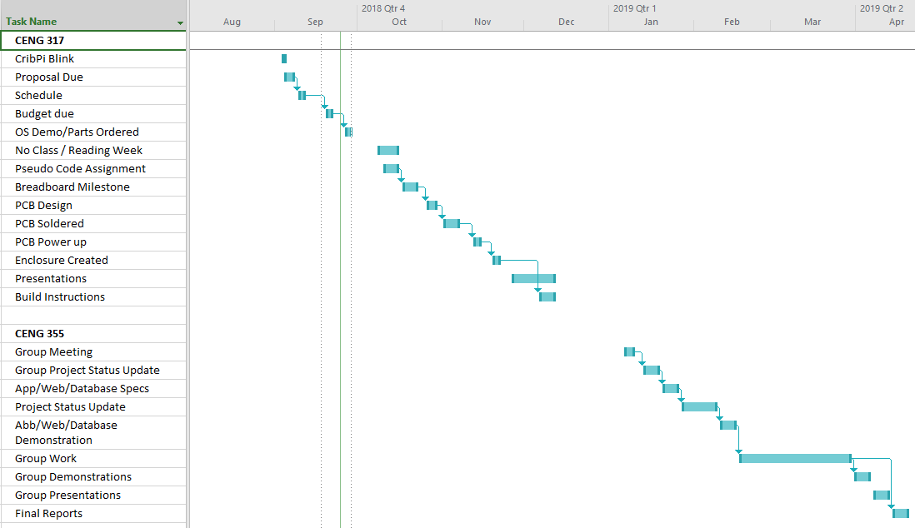

Figure – Gantt Chart

This project took us approximately fifteen weeks to complete during the winter 2019 semester. The majority of core Android development took place in the fall 2018 semester as part of the software programming course. From there, JRD Developers built the hardware on top of the Android application as to create a polished and completed product. Having all of the parts in hand and following the included build instructions, it should take an individual(s) approximately one or two weekends to complete the hardware build. This is assuming he or she has a reasonable grasp of intermediate electronics and programming.

## Software specifications

### Application Specifications and Breakdown

Ryan will be responsible for refining and updating the current version of the Android application. He will update, modify, and adhere to new ideas of the project based on weekly meetings and discussions. Extensive testing will be performed on a number of devices owned by members of the group. Both Delroy and Ryan will jointly be responsible for creating a basic website that will allow the user to login to their created account and using the device, hosted on an Apache web server locally on the Raspberry Pi. They will also be responsible for refining the site for smooth operation and potentially advanced data and metrics which will provide further detail not available on the Android application regarding statistics and hardware data, if possible.

### 

### Database Specifications and Breakdown

The application will be collecting the data and send the results to Google’s Firebase. While the person is using the EZ Tracker hardware, it will need to be connected to the internet. After doing extensive research on various ways of utilizing Firebase, saving a limited amount of data offline is something Firebase is capable of doing, which can be sent to the cloud when the device has connected to the internet. Jonas will be responsible for establishing a connection between the EZ Tracker device to Google’s Firebase database. We will not have our Raspberry Pi connect to the Android phone as we had initially intended for the process is slightly too complicated for regular consumers and users. Jonas will also report if any additional information will be needed, created, and added to the database. The database will be implemented with constraints that will prohibit others users from reading and or access unauthorized user data. Other rules will be implemented as needed throughout the project.

### Hardware Specifications and Breakdown

The continual development of our Broadcom Development Platform, the Raspberry Pi, will be a combined effort amongst JRD Developers. In order to progress the project, the sensors must first be combined to a single entity that must be recognized on a sole system. JRD Developers will collaborate to create a new PCB on the open source software, Fritzing that will enable the Pi to work with multiple sensors on a single board. Jonas will be responsible for connecting and testing the hardware components. Delroy will assist Jonas in the SSD1306 OLED display that will read the values from LSM303 Accelerometer and Magnetometer. Jonas will be held accountable for the capacitive touch sensor which will allow the user to control the device. Functionality will include changing what’s being shown on the display, starting, stopping, and restarting the device. This will allow the user to see the data they want to see, especially due to the display being small in size. As the project nears the final stages, the device will have to be re-housed into a more robust, sleek, and compact design. Delroy will be in charge for the redesign and refinement of the case using Corel Draw, and working with the prototype lab for laser cutting. Jonas and Ryan will help with additional suggestions and ideas. The hardware needs to be suitable to be carried by a person over a lengthy period of time, whether by holding on to it, or strapping it onto themselves. Therefore, the device needs to be compact. Measurements and revisions will be made to allow the EZ Tracker to have a small of a footprint as possible.

# Build Instructions

## Budget and Parts

Firstly, a list of parts will be required in order to recreate this project. Below is a breakdown of the prices and parts for each component used to get the project to its final completion. Spreadsheet with hyper links can be found on the EZ Tracker Repository.

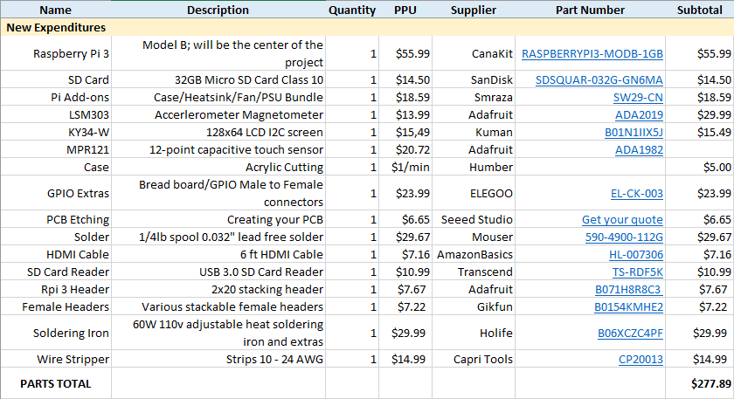

Figure – Purchase List

## Assembly

### Preparing the Pi

In this step we will cover basic Raspberry Pi imaging so you are able to login and access your device to test and drive your sensors. Download the latest Raspbian image. Our recommendation is NOOBS. This will ensure that starting off, you will have almost everything you need if you decide to re-purpose the device later on. However, if you are comfortable with the command line and/or knowledgeable in using and navigating in Linux with commands, I suggest going with Raspbian Lite because this will allow the device to not use as much power, and ensure the greatest compatibility with the Raspbery Pi. You are free to use other operating systems like Ubuntu MATE, Ubuntu Server, Arch Linux, etc. as long as it has systemd because we will be dealing with Python & systemd in this project. There might be some steps that will require different tools to do certain things, such as setting up static IPs using ifupdown on Raspbian vs Netplan on Ubuntu. This guide will be focusing on Raspbian.

1. Download etcher. This program will allow you to burn the Raspberry Pi image to your SD card.
2. Insert your SD card into the SD card reader and plug it into your computer.
3. Open etcher and follow the on screen instructions to burn your image. We found this program the easiest to use. Extra documentation if needed.[1]
4. Insert the SD card into your Raspberry Pi along the underside of the device, logo facing out. Plug all of the required cables in such as: Ethernet, HDMI cable, mouse, keyboard, power, and turn the device on.
5. Upon boot you will see an option for different operating systems. Select **Raspbian** and follow the on screen instructions to complete the OS install.
6. At this point the Pi should boot to desktop. Follow the additional set up options on screen.
7. Make sure the Raspbian is up-to-date by running:   
    *$ sudo bash -c “apt update && apt upgrade”*
8. Enable I2C. This is the method we will be using to communicated with our Raspberry Pi. Type this command into the terminal:

*$ sudo apt-get install -y python-{smbus,pil} i2c-tools python3-pip apache2 git python{2,3}-dev build-essentials*

1. Type *sudo raspi-config* into the terminal.
2. Go to interfacing options > and enable I2C.
3. Install required Python packages by running:  
    *$ sudo pip3 install Adafruit-{MPR121,SSD130,LSM303} pyrebase*
4. Add this following entry to the sudoers file in order to use all commands without the need to type a password (we will use the user eztracker in this case).
   1. Edit the sudoers file:  
       *$ sudo visudo*
   2. Add this line at the end of the file  
       *eztracker ALL=(ALL) NOPASSWD:ALL*
5. We will be using a static IP address in order to access the HTML/PHP webpage, which will run the python file “eztracker.py”. Edit the “eth0” entry in **/etc/network/interfaces** to setup static address through ethernet. You can use GNU Nano, Vim, or any other text editor of your choice. Make sure that you are editing with root privilege
   1. Open the interface file in a text editor (We will use Nano for our examples):

$ sudo nano /etc/network/interfaces

* 1. Edit the “eth0” entry.  
     **Note: make sure to replace “dhcp” with “static”**:

iface eth0 inet static  
 address 169.254.2.13  
 netmask 255.255.0.0

* 1. Rest the networking using systemd:

$ sudo systemctl restart networking

1. Because EZ Tracker is aimed to be a portable device, it is best to have a smartphone connect to it wirelessly, such as WiFi direct[2]. We will setup an access point on the Raspberry Pi for a phone to connect to. **Note: We never got WiFi direct to fully function. However, we hope that others who may attempt this will achieve success. A work around is mentioned in our Status Report 5.**
   1. Enable systemd-networkd and systemd-resolved

$ sudo systemctl enable systemd-networkd  
$ sudo systemctl enable systemd-resolved

* 1. Create a file called “12-p2p-wlan0” and enter the following:  
     **Note: you can enter any IP address you wish.**

[Match]  
Name=p2p-wlan0-*  
  
[Network]  
Address=172.24.2.13/24  
DHCPServer=yes

* 1. Before we set a custom SSID and password, we must allow wpa_cli to autogenerate the entries for us, and change the credentials that need to be changed:

$ wpa_cli -i p2p-dev-wlan0  
> p2p_group_add persistent  
> p2p_group_remove p2p-wlan-0  
> quit

* 1. Go to /etc/wpa_supplicant/wpa_supplicant.conf. In that file, you can change the the SSID and psk to your preferred SSID and password, respectively.

ctrl_interface=DIR=/var/run/wpa_supplicant GROUP=netdev  
 update_config=1  
 device_name=DIRECT-PB-RPi3  
 p2p_go_ht40=1  
 country=CA  
 network={  
 ssid="DIRECT-PB-RPi3"  
 bssid=56:1d:c5:95:c2:e9  
 psk="friedchicken"  
 proto=RSN  
 key_mgmt=WPA-PSK  
 pairwise=CCMP  
 auth_alg=OPEN  
 mode=3  
 disabled=2  
}

* 1. Test and see if it works

$ wpa_cli -i p2p-dev-wlan0  
> p2p_group_add persistent=0

1. Power down the Pi

$ poweroff

### Breadboarding and prototyping

In this section we will cover basic sensor connectivity to the Raspberry Pi using a breadboard for creating mock layout or design that will be used in the PCB creation stage.

1. Gather the following items: Breadboard, LSM303 Sensor, MPR121, 128x64   
   LCD sensor, and 4 Female-to-Male GPIO cables.
2. Identify the labels on the sensor. For basic usage, we will be using: 3.3v, GND, SDA, and SCL.
3. Identify the corresponding pinouts on the Raspberry Pi. This website is a great tool to use if you are unsure.[3]
4. Plug in the female part of the GPIO cables into the Raspberry Pi’s 1,3,5, and 6 pins (These are 3.3V, SDA, SCL, and Ground), based on the chart from pinout.xyz. These are the pins we are going to be using for this project.
5. Using the connectors that came with the sensors, plug them into the breadboard and rest the sensors accordingly. Below is an example of our sensors connected to the Raspberry Pi.

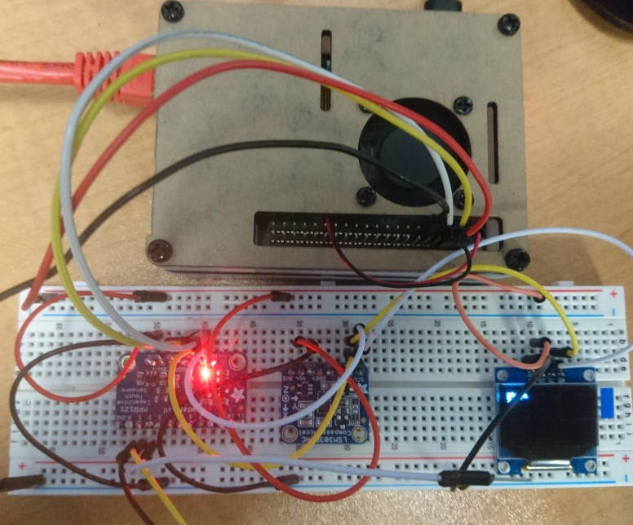

Figure – Breadboard Test

1. Connect the corresponding cables from the Raspberry Pi into the matched holes for the sensor.
2. (Optional but recommended) Power on the Raspberry Pi to see if the sensors are being detected correctly by viewing their address values.
3. (Optional but recommended) Open the terminal with *ctrl + alt + t* and run the command: *i2cdetect –y 1.* Ideally, the resulting output should be as follows, if not double check your connections and try again.

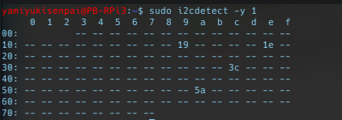

Figure – I2C Address Test

1. Voila! You have your mock up sensor connection!

### PCB Design

This is part of the project that needs to be proceeded with care and caution. It is advised to double check your designs before purchasing etching and cutting services. For this step, Fritzing will be used. It is an open-source application that allows the user to easily create PCB schematics for different development platforms. It is highly customizable and easy to use.

1. Download and extract Fritzing. Installation notes can be found on the Fritzing download page for various operating systems.
2. (Optional) Download the AdaFruit Fritzing Library[4]. Very useful if you want to take the extra step and create a mock or your own connection/designs in Fritzing.
3. Download our Fritzing file on our repository and open it. From the PCB tab, you can make changes at your leisure and pick it apart to see how it was made. Below is an image of our design.

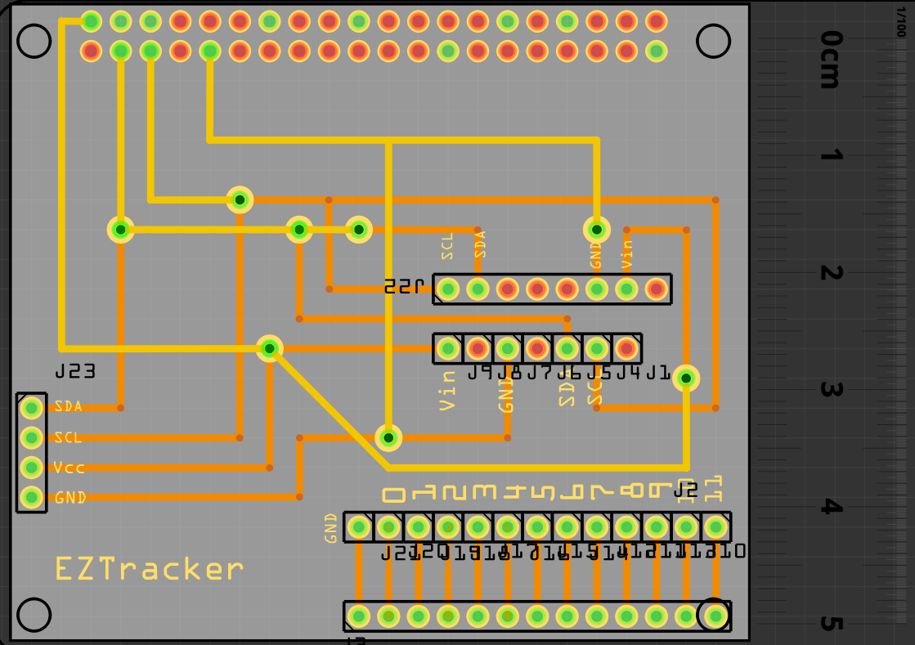

Figure – PCB Design

1. Export as a gerber file (the format primarily used in create a physical PCB). *File > Export for Production > Extended Gerber* and select an appropriate folder.
2. Zip/Compress the folder containing the gerber files and send them to your etcher of choice.

### Soldering

Once you have your PCB etched, we are ready to solder the parts together. Again, please double check your design before finally soldering.

1. Gather your sensors, copper wire, wire stripper, the pin headers that came with the sensor, your PCB, solder, and soldering iron.

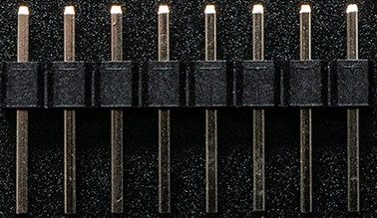

Figure – Pin Header

1. Solder your headers that came with your sensors, pictured above, to the corresponding holes. Put the longer end of the headers into your breadboard and place your sensor holes into the upright pins and solder all of the pins. This will ensure your sensor doesn’t move too much during soldering and a sturdy connection. **Note: Watch this video[5] on soldering tips for additional help**. **Solder in a well ventilated area and use safety glasses.**

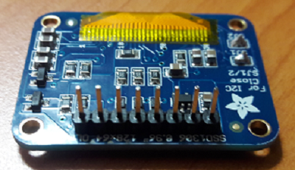

Figure – SSD1306 underside

1. Solder your vias on your PCB. The easiest method I found, was to strip your copper wiring, stick it into the breadboard, and slide one via onto it so that it is flat and stable for soldering. Imaged below is an example, and repeat for each via. Once each via is soldered, snip the excess wire with cutters.

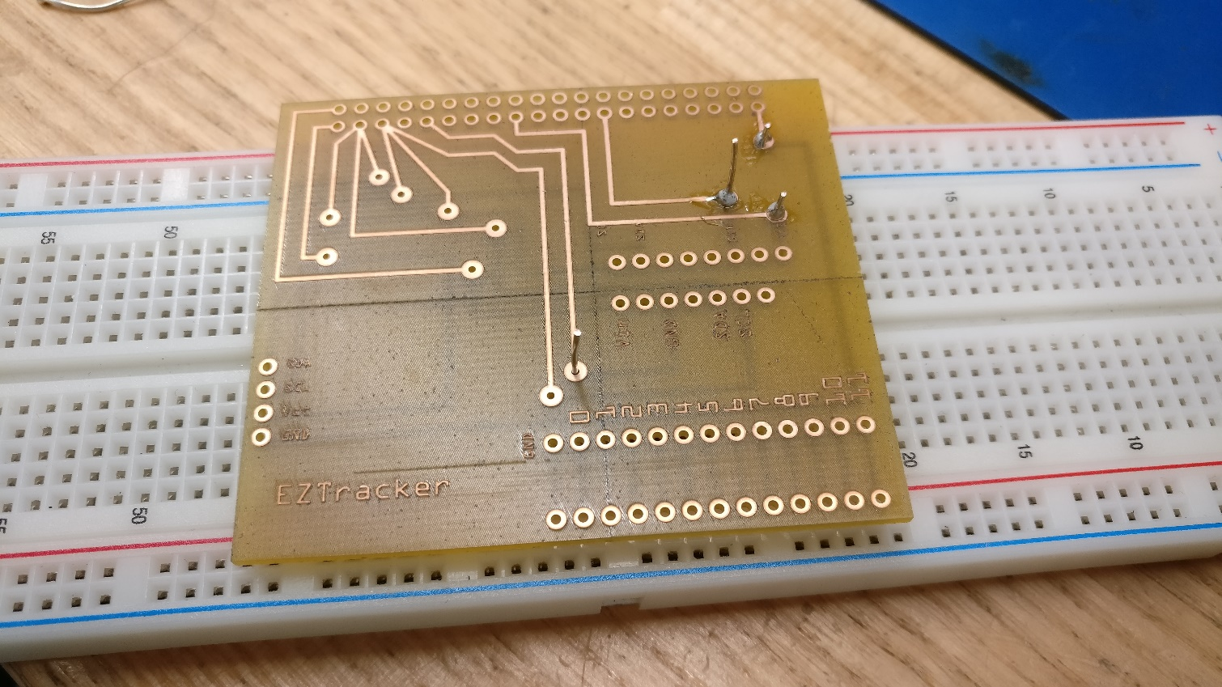

Figure – Soldering PCB vias

1. Solder your stackable headers. Using the breadboard again, take some extra copper wire from the snipped vias, or strip more, and place it into the female part of the header. The more, the sturdier. Flip the header over and plug it into the breadboard. Place your PCB onto the pins sticking out and solder the connections. An example is imaged below.

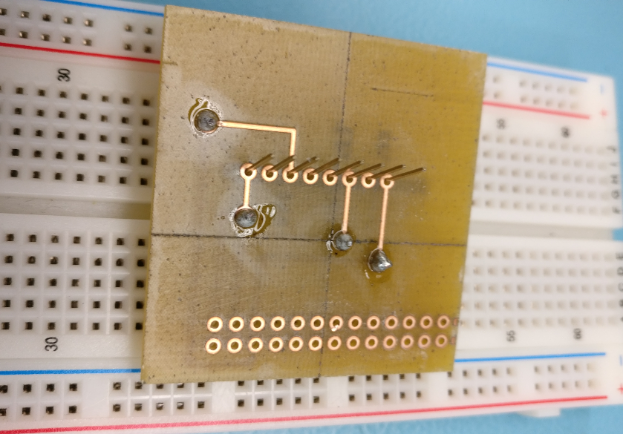

Figure – Soldering stacking headers

1. Repeat the process for the 2x20 header for the Raspberry Pi. It’s not entirely necessary to solder all of the holes, but it ensures the PCB does not bend as much.
2. Your soldering should be complete. Plug everything in accordingly, and you should be ready for the next step! Reference image below.

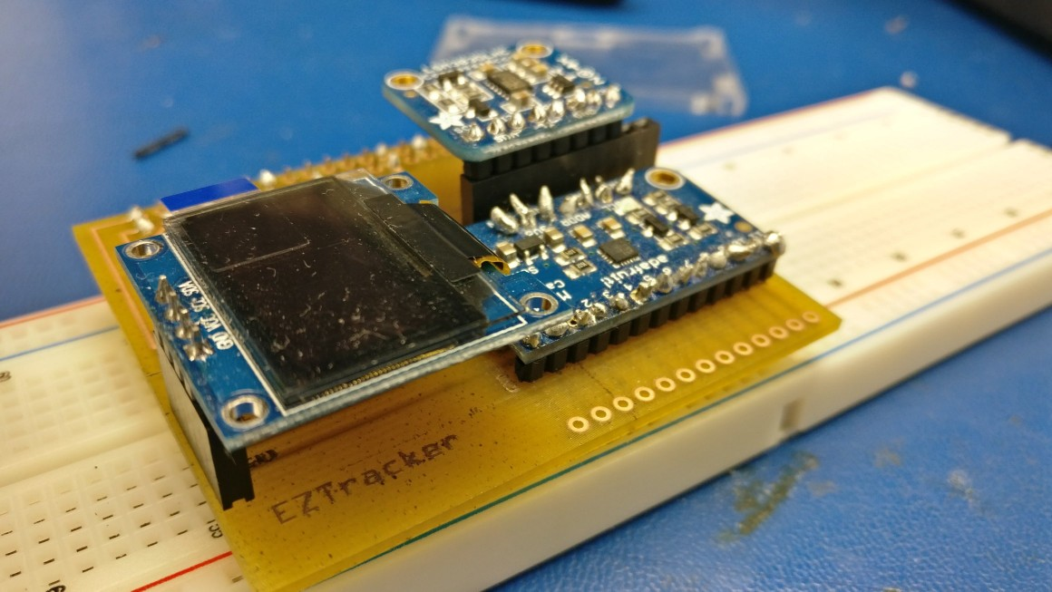

Figure – Completed PCB

### **Power Up**

Once everything is plugged in, and you have double checked your connections, power on your Raspberry Pi.

1. Open up the terminal with *ctrl + alt + t* and run the command *i2cdetect – y 1*.
2. Hopefully everything is in working order. If so, you will see the following address values.



Figure – PCB Address verification

1. If not, go back and check if your sensors are connected accordingly.

### Unit Testing – LSM303

For this portion, you will need an internet connection as you will be required to download libraries in order to test each sensor.

1. Make sure your Pi is up to date with the latest packages. Run *sudo apt update* in the terminal to make sure everything is up to date.
2. Navigate to the */Adafruit_Python_LSM303/examples* directory.
3. Test your sensor by running *python simpletest.py*. Your readings should look like the following:

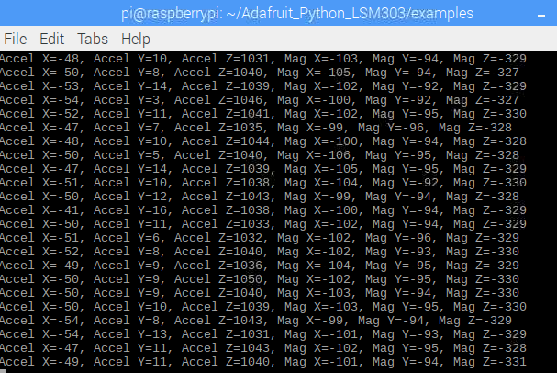

Figure – LSM303 Test Output

1. You can test the readings by moving your device in different directions with different speeds. You will notice the values changing accordingly.

### Unit Testing – MPR121

1. Download the test code from Jonas’s repository with:

*wget https://raw.githubusercontent.com/YamiYukiSenpai/MacroKeyTouchSensor/master/cap-touch.py*

1. Run the code:

*sudo python cap-touch.py*

1. You will then be able to touch each of the nodes on the sensor, or you can have individual wires running from each position. Below is an example output.

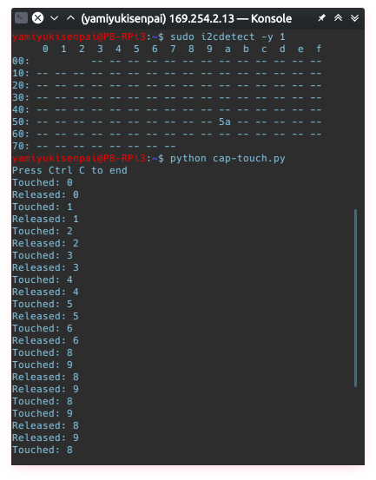

Figure – MPR121 Test Output

### Unit Testing – 128x64 Monochrome LED

1. Download the test code

git clone https://github.com/adafruit/Adafruit_Python_SSD1306.git

1. Navigate to the *Adafruit_Python_SSD1306/examples* directory and run the example code using *sudo python shapes.py*. The following should look like the placeholder image below.

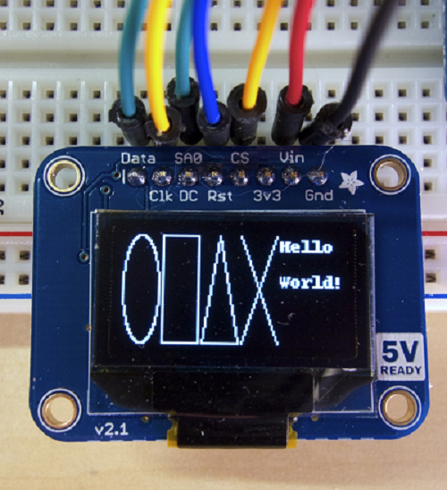

Figure – SSD1306 Test Output

### Production Testing

We have provided a case file (Created with CorelDraw x6) for those that wish to continue further for potential real world use that can be located on our Github repository. This case will ensure your sensors, Pi, and PCB are protected all while providing enough room for you to remove the sensor at your leisure. For portability, there is definite room that can be improved upon if you wish to make the device smaller and more portable. This concludes the end of the build instructions, and below is an image regarding the final product.

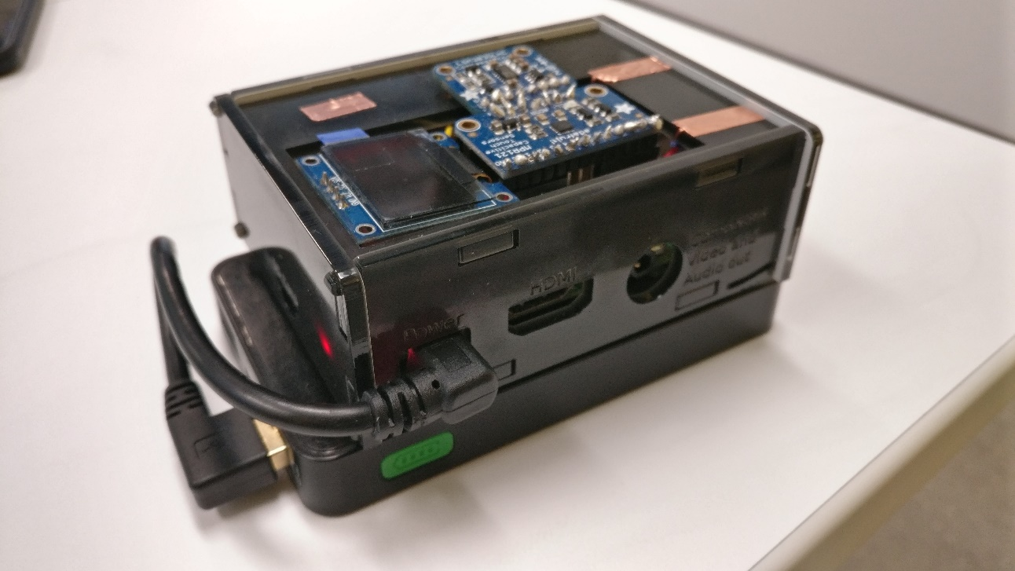

Figure – EZ Tracker Final Product

# Overall Description

## Product Functions

The application has five major functions. The functions include daily step counting, weekly step counting, calorie tracking, updating user information, and setting a weekly goal. Before diving into the EZ Tracker’s Android application, JRD Developers first needed to establish what data the application would use, and how to manipulate that data for EZ Tracker’s goal. We needed to centralize our criteria around the main function of the application, and it was determined to be the step and calorie tracking. With some research, we were able to find two key pieces of information that would be required from the user to ultimately calculate the approximate calories per step. The two metrics needed for the calculations are **weight** and **height**.

Firstly, the user’s weight can be used to determine the approximate calories burned per mile based on the constant 0.57. This is not an official constant but it was derived by reverse engineering a Fitbit (Banas, 2018).

Calories *Per Mile = 0.57 * Weight (lbs)*

Secondly the user’s height can be used to roughly determine their stride length. Stride is the length of one step. By using the constant 0.414 (Sutton, 2016), multiplied by the user’s height in centimeters, we can roughly determine a user’s step length, or stride. We personally derived 0.414 from an average of the two constants 0.415 (Male) and 0.413 (Female), as we did not want to complicate users with a designated gender.

*Stride Length = 0.414 * Height (cm)*

Thirdly, based on the variable above (stride length) we can now calculate approximately the amount of **steps a user will walk in a mile** by converting a mile to centimeters (160,934.4 cm) and dividing that number by their stride length (step length).

*Steps per Mile = 160,934.4 (cm) / Stride Length*

Lastly, based on the above variables Calories per Mile and Steps per Mile we can then determine the Calories per Steps by dividing the two respectively.

*Calories per Step = Calories per Mile / Steps per Mile*

Calories per Step can then be used to multiply into the user’s steps and thus determine their calories based on their weight, height and steps taken.

Afterwards, the matter of determining and putting the steps on to the database for the Android application to read and manipulate was the next focus. The LSM303 Accelerometer already came equipped in reading values from it’s X, Y and Z axis using the test code provided by Adafruit. What we needed to determine was how we could get a step from such readings. What Jonas decided to do was get all of the axis values every 0.5 seconds (which we determined to be the amount of time for 1 step through our own personal stepping), and compare the previous axis values to the new axis values. This method could then detect the changes in movement. By then looking for a value difference of about ±160 (based on our own tweaking and testing through walking with the device) in any of the axis values, the step counter would then increment by 1.

With the key points in place, we then could work with our previous semester’s database and Android application. To get an approximate overview of how the entire project tied together, we created a simple use case below. Next will be the topic of the Android app.

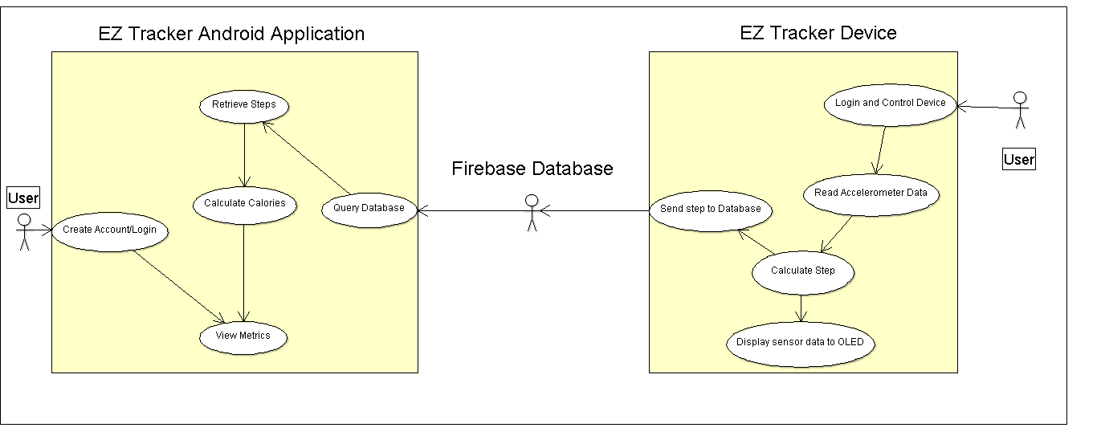

Figure – Use Case Diagram

## Android Application Overview

Reiterating our idea behind the EZ Tracker in keeping it user friendly towards our target audience, we wanted our Android application to mirror that ideal. Initial UI (user interface) designs for our application were a collaborative effort between JRD Developers in the semester 5 class Software Programming (CENG 319). Mock up designs were created in NinjaMock[6] and we had initially planned for two modes, advanced and simple. The idea was to, by default, display the simple layout for beginner users and allow more tech savvy users to switch to an advanced mode for advanced metrics and data. As a group we collectively decided to put that idea aside as it would increase programming complexity. Overall, we are proud that our current application functions as intended and that our initial mock up designs approximately reflect our current version. Mock up designs are shown below.

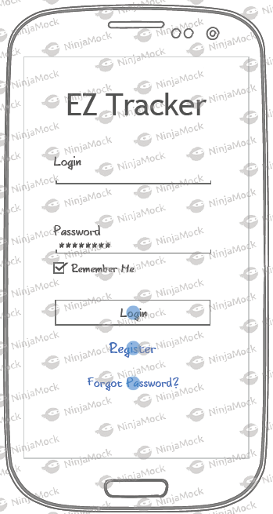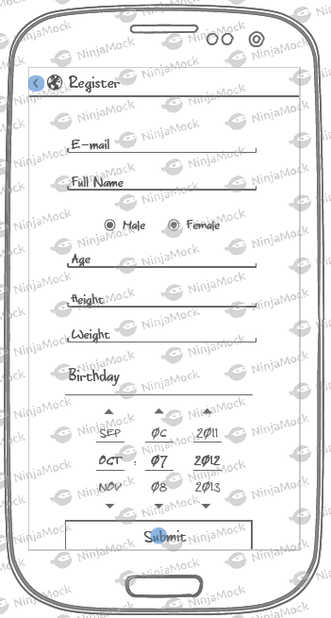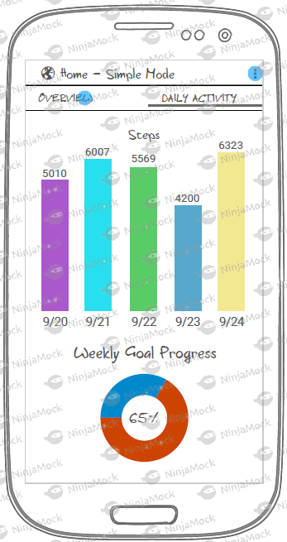

Figure – Android Application Mockup

Upon opening the application, the user will be prompted with a simple log in screen. With the option to login, reset a password, create an account and change language, we believe this to be a relatively simple user interface for any demographic to use.

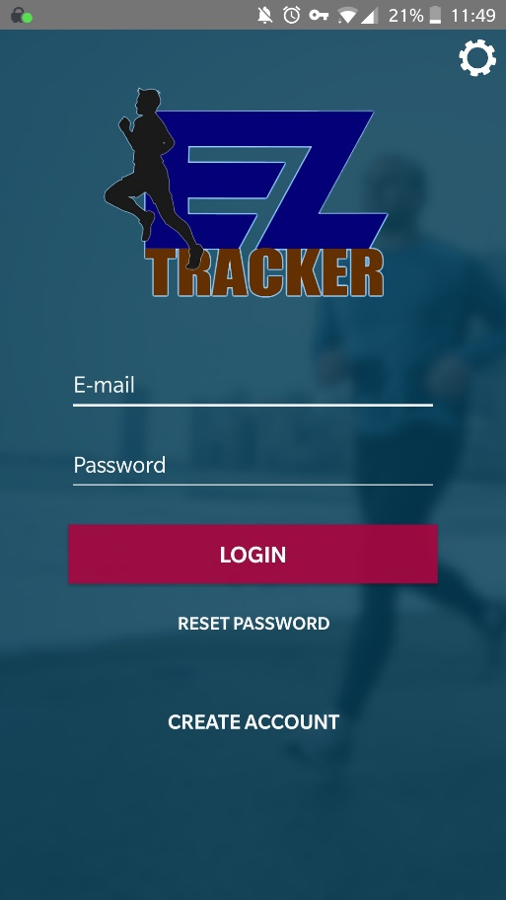

Figure – Login Screen

The registration was a fair amount more complex as we needed to ensure and co-ordinate that information entered upon account creation would not lead to any unexpected errors during use. This led to an adequate logic checking rule for each field devised and tested by Ryan to ensure Android application integrity. Along with logic checking, Ryan also realized that all values involving steps needed to be initialized to zero in the database or else the application would immediate crash upon login. Android application APK and code can be found in our GitHub repository. The link can be found in the proposal at the beginning of the technical report. The following is a screenshot of the registration page.

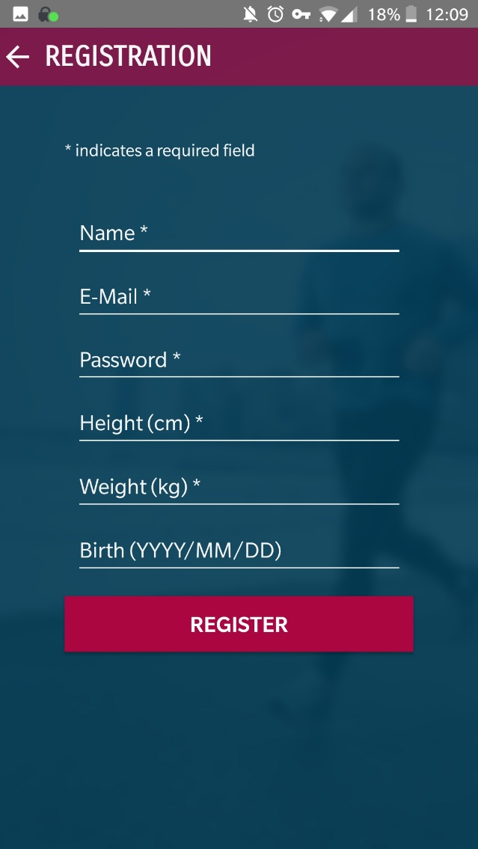

Figure – Registration Screen

After creating an account and logging in using the required credentials, the user will be presented immediately with the home screen. By allowing the user to go straight to all of their metrics upon launch, we believe this to be the most streamlined designed for our target. The user will be able to simply look at their screen, gauge their progress, and continue with their day. The user is also able to set a weekly goal for themselves as we believe setting goals to be an important part of progression. The charts are a 3rd party resource called MPAndroidCharts[7], an open source repository that allow for superior customization in displaying graph data in Android. Below is a screenshot of our Home screen.

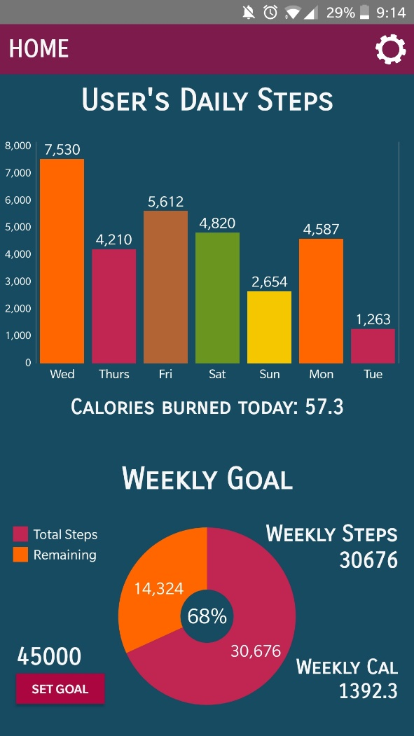

Figure – Home Screen

Again, opting for a simple experience, the user can go into the settings and will be presented with just enough options to not feel overwhelmed. The user will have the option to update their metrics, ideally weight if any changes are observed, in order to achieve as accurate of a calculation as possible from our caloric formula. From here the user can also view their personal information, understand a little more about JRD Developers, switch to French if inclined to do so, and more that could be implemented at a later time. Below are reference pictures of the Settings and Update Information activities[8].

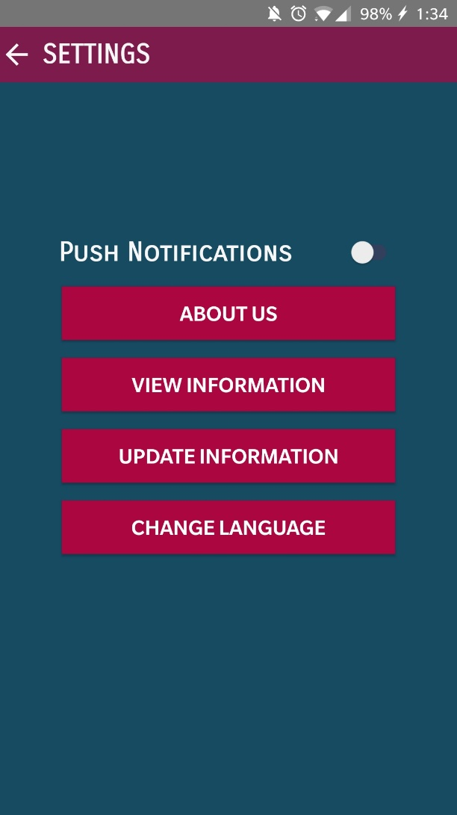

Figure – Settings Screen

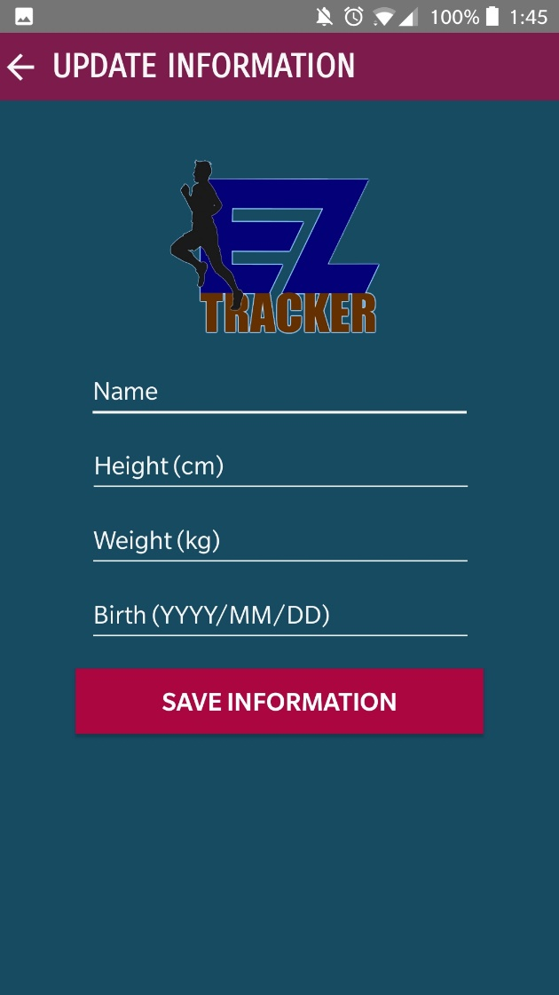

Figure – Update Information Screen

## EZ Tracker Web Server Overview

With Jonas working on attempting a Wi Fi Direct connection to allow a mobile device communicate one to one with the EZ Tracker device, a contingency plan needed to be developed in case his effort was not successful. With the entire EZ Tracker program running in Python from a CLI (Command Line Interface), it was crucial to find an appealing and simple way to get the user to interact with that fairly complex underlying method. Employing skills and using knowledge developed in our Semester 4 Internet Programming (CENG 256) course, along with a little bit of research[9], we realized we could launch the entire program using PHP. In conjunction with HTML, we could host the entirety on a locally hosted webserver using Apache and employ it as a login interface. Below is the login design.

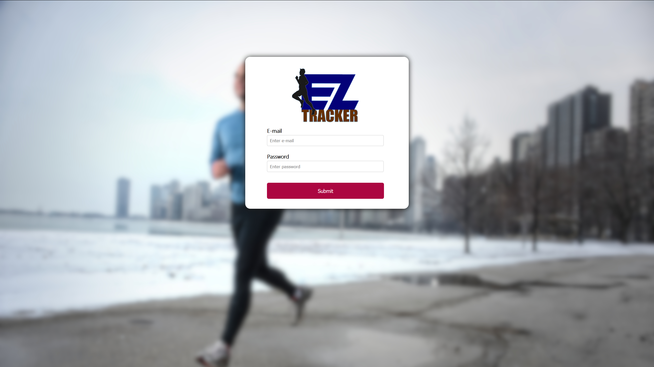

Figure – Web Interface Screen

## Operating Environment

The software will operate in conjunction with the EZ Tracker platform (Raspberry Pi) as the main engine with an operating system that has systemd (i.e. Raspbian, Ubuntu Arch), Python 3, & wireless network interface. The following I2C devices that are connected to the Raspberry Pi are the MPR121 capacitive touch sensor/effector, LSM303 accelerometer, and an SSD1306 OLED monochrome display. The mobile device’s operating system need to be powered by Android 5.0 Lollipop and above. On the back end, the system will be linked to Linux-based Apache web server and Google’s Firebase database for data storage and retrieval.

## Design and Implementation Constraints

The program will be created using the Java programming language with Android Studio. Any smartphone that is capable of running Android 5.0 Lollipop and above will be able to use this application. The following constraints can pose a possible threat to the complete functionality of the system:

* User’s Android version may not be up-to-date to install the application.
* Device may not have enough storage space for the installation (mobile app).
* Google play store may not be available in the user’s demographic location.
* Resolution on the Android device falls below 1080x1920.

# Assumptions and Dependencies

While the system is fairly simple to use, the assumption can be made that the system may be affected due to certain situations. These include but are not limited to:

* Browser compatibility: The system might not be able to run an outdated browser. Thus, users a being recommended to have the most current version of the browser installed on their device.
* Android OS Compatibility: The system might not be able to operate on versions of Android that are older than Lollipop, which is deemed outdated by the developer and may pose security risks.
* Environment: The EZ Tracker hardware is advised in its current state to be used only in dry environments. Currently, exposed hardware limits the use of the device as water can permanently damage comments and can inhibit proper function.

For the system to be fully functional and effective, it will be dependent on the following:

* Internet Connection: Internet access is absolutely necessary for the system to function currently. The Android application requires a database connection to retrieve graph data and create an account. In addition, the EZ Tracker device must have internet access as well to update the database with step values. Improvements will be discussed in the Recommendations section.

## Hardware Interfaces

The EZ Tracker app interacts with a few hardware components to accomplish its tasks. Firstly, system is powered by a Raspberry Pi 3 B+ as its main engine. It also uses a small 128x64 SSD1306 OLED Display for simple, on the fly, statistics. The display will show login verification, steps, status of the program (paused or running), and when the user logs out.

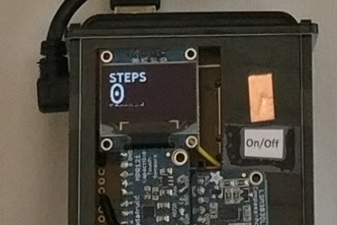

Figure – EZ Tracker Step Output

Tracking data is made possible by the LSM303 Accelerometer and Magnetometer, while the MPR121 12-Point Capacitive Touch Sensor offers seamless interaction between the system and the user. With the hardware in place, the final step in making this truly an ‘EZ Tracker’ was to make it portable. Our original idea of keeping the battery internalized was ideal and we had recycled parts from a portable power bank imaged below. We deemed this to be the best solution in powering our device while keeping the final product as low profile as possible.

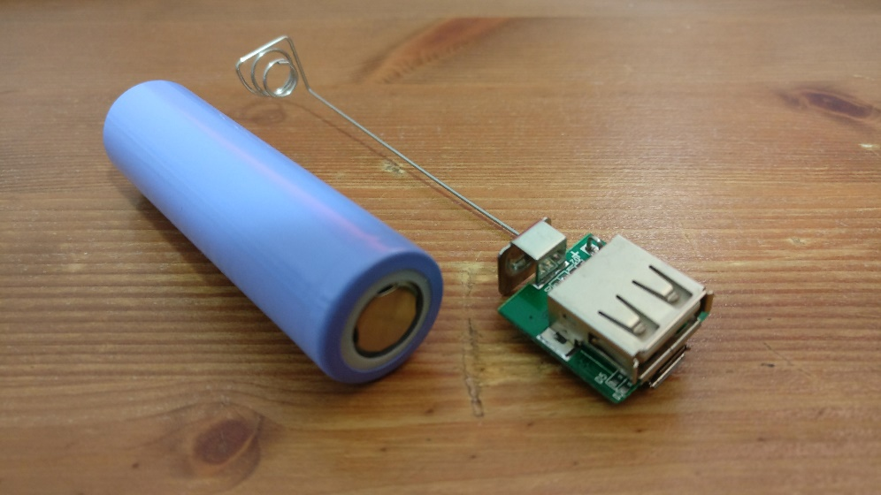

Figure – Power Source

As Delroy made the appropriate adjustments to our case pictured below, we made the unfortunate discovery that our battery interface, pictured above, shorted and no longer worked.

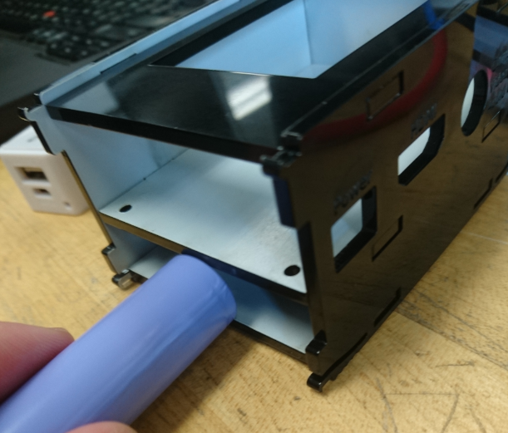

Figure – Case Error

Fortunately, thanks to quick thinking and resourcefulness, we were able to procure a battery solution that not only had a larger battery capacity, but actually *decreased* the overall height of our design while making the battery modular for replacement if necessary. By using industrial strength Velcro and creating modifications to our case, our group was able to successfully create the handheld EZ Tracker platform.

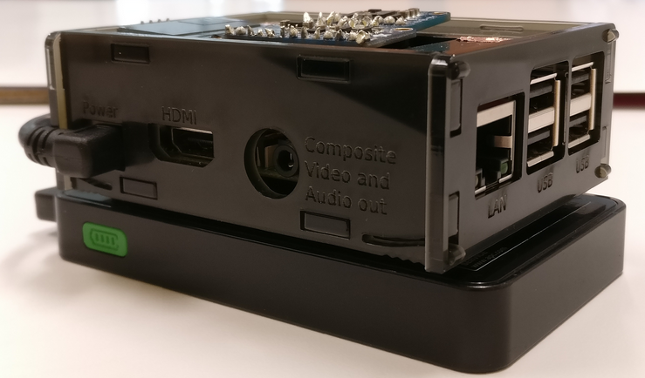

Figure - Final Revision

Keeping it simple, we opted to go for a total of three capacitive buttons for our design. An On/Off or Sleep state, Pause/Resume, and a total Log Out of the device, assuming another user wished to log in with their credentials. These were implemented with simple copper wiring (22 AWG) and taped into place with Copper Tape to provide a simple yet effective touch interface. Data collected will be recorded and stored to the online database. The local values will be read to the small built-in screen, as well as displayed into the EZ Tracker application. Reference image pictured next.

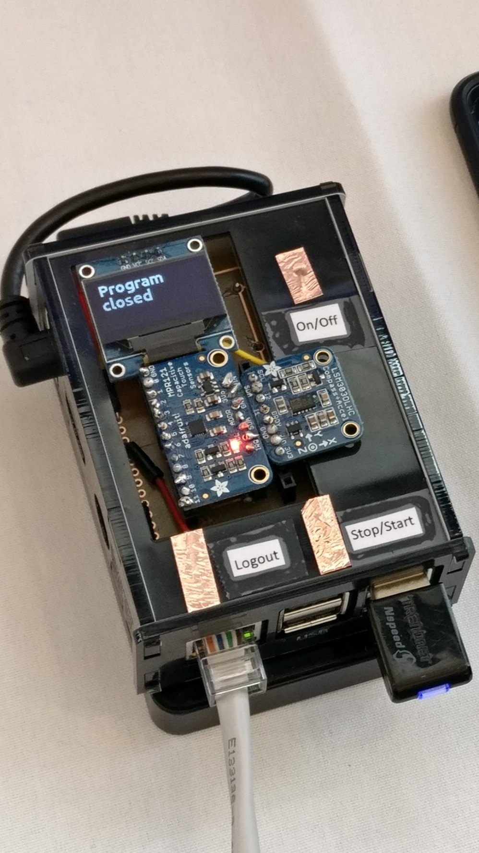

Figure – Labels and Buttons

## Software Interfaces

Connections for the EZ Tracker

* Database: Google’s Firebase will be used as the database. Used for storing tracking metrics such as direction, speed, steps, etc. Will only be an inbound for our hardware, and an inbound/outbound for our Android application connection. The main parent is a random string generated by Firebase itself as we did not want any personal information being stored in case of a breach. Database layout imaged below for a single user.

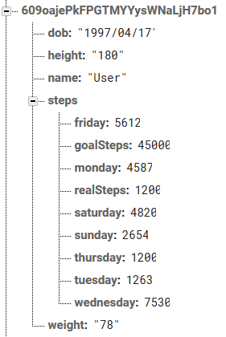

Figure – Database Layout

Connections for the EZ Tracker Android application

* Operating System: Internet Connection (HTTP) to send a request and receive e-mail notifications/instructions for password reset (SMTP).

## Communications Interfaces

EZ Tracker will employ communication through a number of interfaces. The first method being the database between the Tracker and the phone. The logs will be stored on to the database from the EZ Tracker hardware and corresponding statistics from the database onto the application (via HTTP/Internet). Secondly, users will have their e-mails tied to their accounts on the app. This will allow email notifications to be received without storing any mobile number information (via SMTP).

# System Features

## Home Screen

### Description and Priority

This mode will be the main attraction point for the app. In general, users just want their product to work. It will display the simplest forms of data required to be considered a health tracker (i.e steps and calories). At a glance, users will be able to see all of the information they need to.

Priority Level[10]: High

Risk[11]: 3

Cost[12]: 3

## Daily and Weekly Goal

### Description and Priority

These features are located on the Home Screen and are the major features revolving around the EZ Tracker application. The daily goal and weekly goal are presented as a bar chart and pie chart, respectively, utilizing the MPAndroidCharts library. Users can view their entire step progress with these charts in formats that are simple to interpret.

Priority Level: Highest

Risk: 5

Cost: 5

## Settings

### Description and Priority

The second page after the Home screen. The settings page will allow the user to go into more detail with the EZ Tracker application. This section can lead the user to view and update their data which will reflect in the calorie formula, change language preference, and view information surrounding the EZ Tracker team.

Priority Level: Low

Risk: 1

Cost: 2

## Stimulus/Response Sequences

Preconditions: The user is logged in to the EZ Tracker device and the user already has an account. The user is also logged into the Android application. Both devices have an active internet connection.

1. User wishes to see their up to date tracker stats.
2. User opens EZ Tracker and the Home page is displayed (calories, steps, goals, etc.).
3. User is able to view the basic statistics and metrics they wish to see for their general health/activity.
4. User is able to set a goal and that number will reflect on the Pie Chart (user will not be allowed to set a goal lower than their current steps).
5. User is able to update their personal information in the settings activity (weight, height).
6. Their changes will reflect on the Home page as calorie values will change according based on the EZ Tracker calculations.

# Functional Requirements

REQ-1: User must have an active internet connection

REQ-2: Must download and install app from the Google Play Store or Github repository.

REQ-3: Must be using a device that runs at the minimum Android 5.0.

REQ-4: User must register and log into the application and matching EZ Tracker hardware.

# Other Non-functional Requirements

## Performance Requirements

Upon opening the application on the device. The user will be able to see their up-to-date statistics within at least 5 seconds. Otherwise no data will be displayed at all as at that point it may be deemed that the user does not have an active internet connection. The OLED display on the EZ Tracker will continuously update in real time, give or take a half second, since the numbers are generated locally. The user will be able to pause or resume in the counting of their steps at their leisure with the use of the local capacitive touch buttons. In the case of querying the database, connection can depend on the users signal strength and will timeout if not successfully refreshed after 20 seconds.

Due to our target audience being the older and not so tech savvy generations, we need to assume that the user will have an older device in terms of specifications (i.e. a relatively weak device with a low amount of RAM and CPU processing abilities). Therefore, the Android application needs to be light in its resources and will have to perform relatively well with older hardware. This will be tested with a number of older devices we have on hand. Additionally, battery life is critical for the EZ Tracker as users are not likely going to be near an electrical source throughout their walking or running. Under the assumption that the user will not be turning it off, the device should last throughout their whole workout, and then some. The user should not be worrying about the device’s battery life at all during their workout. Using Raspbian Lite allows us to achieve this because the operating system does not come with a graphical interface, which uses up a lot of resources, such as graphics processing, which EZ Tracker does not need.

## Safety Requirements

### Database corruption

The information in the database can be backed up into JSON format with a command from an authorized administrator, or automated to ensure redundancy and version controls in such a catastrophic case.

### Security Requirements

The mobility domain has a privacy sensitive nature, specifically with regards to the location tracking of users. In order to create a viable offering for the user we will build a simple, transparent system that can be understood and trusted by the people that are using it. In order to build trust with the users of our system, the system shall make use of the following strategies:

* Anonymization & aggregation, so that information may be shared safely without disclosing personal information. This step has been disclosed above with an image of a database entry.
* Encryption, for all data that is privacy sensitive, but must be persisted on the server in order for basic functionality
* Open source, this will ensure that other programmers, developers or engineers will be able to verify the source code, and help make the EZ Tracker platform much more secure and diverse through contributions.
* Permit the use of anonymous avatars and/or aliases (avatars may be implemented in potential future revisions). By permitting aliases or nicknames, users can remain anonymous in the case of a database breach.
* Give control to the end-users over private data (a delete account option; to be implemented in future Android application versions)

# Software Quality Attributes

* **Usability:** Checking that the system is easy to use and intuitive for the people not comfortable with current technology.
* **Reliability:** When all requirements are met, the device and application work in conjunction as intended with minimal crashing and errors.
* **Performance:** Both hardware and software operate with minimal latency when the appropriate requirements are met.
* **Maintainability:** Any crashes regarding the app will prompt the user to send the crash report to the developers (to be implemented in further revisions).
* **Installation Requirements:** The user’s mobile device must at least contain 1GB of RAM and Android 5.0 or higher.
* **Documentation Requirements:** Login screen will contain a help section to inform users of the proper application usage to ensure smooth functionality.
* **Monitoring:** Users will be able to view almost, if not all, of the data available on the database under their account (may subject to change based on further revisions of the application).
* **Localization and Suggestions:** Users will be able to request language options and application features through the use of the feedback section located in the settings of the application (to be implemented in future versions of the application).

# Status Reports

## Status Report 1

The objective of this report is to provide details on the status of all team members working on the EZ Tracker Internet of Things project, and the current progress we have made so far.

**Hardware**

The hardware components of this project include the integration of three sensors with the Broadcom development platform (Raspberry Pi). The sensors we are using include a LSM303 Accelerometer & Magnetometer, a SSD1306 Monochrome OLED, and a MPR121 Capacitive Touch sensor.

**Acquisitions & Financial Status**

To date, we have acquired an extra LSM303 Accelerometer & Magnetometer, SSD1306 Monochrome OLED, and MPR121 Touch Sensor. The LSM303 by itself cost $42 including shipping and the SSD1306 was $14.40. During production, we believe it is a wise decision to purchase extra parts as mistakes or breakages may occur which can result in a delayed or rushed project. Since we have decided to acquire extra hardware, this is added cost to our budget. Therefore, our financial status has changed marginally.

**Challenges**

Due to the hardware being portable by nature, we are aiming for all sensors to fit onto one PCB as we aim for a compact device. This is a bit challenging since the working space within the Raspberry Pi development platform is limited. However, we have found an online resource[13] to assist in this regard. Jonas has begun trials using all of the sensors on one breadboard. Once the hardware can interact seamlessly, Jonas will design the PCB on Fritzing, with added assistance from Delroy and Ryan when required. We also felt it might be a good idea to use a Pi Zero for a smaller form factor. Our group can discuss this in the following weeks.

**Opportunities**

Delroy and Ryan are currently working on the website and revising the Android application. They are drafting basic designs for it with the plan of having a consistent interface between the website and the application. Their main goal at this point is to read data from Google’s Firebase, and focus on design later. Having worked, and successfully interacted with the database on the Android app, the web based version should flow together with few issues.

Sincerely,

Team EZ Tracker

## Status Report 2

This report is to provide an update on the progress of the EZ Tracker project to date. Its main focus is on the integration of the formerly independent hardware and software components into one cohesive unit.

**Hardware Progress**

As indicated in our last update, the aim is to integrate three sensors into one cohesive unit, operating on a single PCB. That hardware is also to integrate with an Android application working with an online database at the back end. At this point, we are still in the process of designing the PCB for the project, but hope to complete this task by the end of the week. This undertaking shouldn’t be that difficult as we have already integrated a working prototype of the sensors on a single breadboard. We are also in the process of designing the enclosure to be sent to the prototype lab for production. Based on our hardware design, this process requires very little or no modification to the enclosure design used for our individual sensors. We already have the android application working with the database, but now need to have the individual hardware read and write data to and from the database. Since we aim for a compact hardware design, one of the challenges we were facing was to get the sensors to work in a distributed fashion on the PCB, rather than a stackable one. However, our conceptual design overcame that challenge. Therefore, based on our current progress, the project is on track. As outlined in our work breakdown schedule, and also within the budget. Hence, at this point, we have met all our objectives as defined in our proposal.

**Acquisitions & Financial Status**

No extra purchases have been required or incurred since the last progress report.

**Challenges**

A challenge we were having with the android app was to get the charts to display the dates correctly. We needed to determine how to manipulate the bar chart to get the current day of the week. This was required to display the current day on the right hand side of the graph. However, after much effort, we have resolved the problem and the charts are now presenting the inputted data correctly along with the correct day of the week. Regarding working with the sensors, we ran into issues trying to multi-process the sensors. We are in the middle of coding sensors working with one another and should have it completed within the next week.

Sincerely,

Team EZ Tracker

## Status Report 3

This report is to provide an update on the progress of the EZ Tracker project to date. Its main focus is on the integration of the formerly independent hardware and software components into one cohesive unit.

**Hardware Progress**

As mentioned in the previous report, the PCB has been fully designed to take into consideration the integration of the three sensors. It was subsequently sent to the prototype lab for etching and has since been soldered and integrated into the Pi. However, the headers to accommodate the sensors are yet to be soldered. We are anticipating the design and hardware integration will be fully functional the first time around. To this end, Jonas is continuously working on integrating the sensors into a single working unit. Additionally, we are still contemplating migrating the project to a Pi Zero. However, that consideration is dependent on the success of the PCB integration with the hardware sensors. That will make the migration to a new platform much easier. As it relates to the enclosure, Delroy is in the process of determining placement for a battery pack to power the device independently. Not to mention the added challenge of thinking about a design if we decide to downsize for the Pi Zero.

**Challenges**

The process of integrating the software with the hardware is a bit tricky. Authenticating the Firebase portion is proving to be tedious, as the guide for Python-Firebase on PyPi’s website did not work. After further research however, Pyrebase[14], a more up-to-date alternative, was the solution Jonas was able to utilize to successfully create an authenticated connection to our database. This portion of the work is proving to be the most time consuming part of the project. However, we are working assiduously to ensure the entire database completion and hardware integration by the end of next week.

**Financial Status and Remaining Work**

There has been no change to our current financial status as no new purchases have been made. Hence, our budget has remained the same. However, that might change if we decide to migrate the project to the Pi Zero platform. So as it stands, as indicated in our project breakdown schedule, we are currently on track and within budget. By the end of next week, we hope to have the entire project fully integrated and working together as one cohesive unit.

Sincerely,

EZ Tracker Team

## Status Report 4

This report is to provide an update on the progress of the EZ Tracker project to date. Its main focus is on the integration of the formerly independent hardware and software components into one cohesive unit.

**Overall Progress and Troubleshooting**

As mentioned in the previous report, the PCB had been fully designed. Unfortunately, it did not work as we had intended. Our PCB would detect the sensors correctly, but when running the program, it would not co-operate correctly and errors were thrown we had not seen before. We had determined it to be faulty wiring as the project would succeed on a breadboard. We reduced the number of Pi GPIO pins (as indicated between v1 and v2 found on our repository) we were connected to and branched our vias to accept inputs from the 3 sensors at once, essentially simplifying the overall design.

In addition, we had our case designed by Delroy as per our group discussions. We had proposed a compartment below to house the rechargeable battery, and a port to charge and power our device. After receiving the completed product, we realized we had measured incorrectly for the battery, charging, and power source compartment. We have re-measured and Delroy will be in the process of re-designing in Corel Draw over the weekend, to be ready for next week’s milestone.

Lastly, Jonas is in the process of working with the Raspberry Pi’s Wi-Fi direct system. This will allow the user to access an apache website hosted on the device, from their phone. This makes it easier for logging in and running the program from the mobile device. Jonas is still in the process of configuring this system and managed to get it working. Unfortunately, the Wi-Fi direct had spontaneously stopped co-operating and is trying to figure out reasons and solutions to correct it.

**Financial Status and Remaining Work**

There has been no change in our financial status and our budget remains the same. Given the amount of remaining work left, we will most likely not be able to make the switch to a Pi Zero. We realize that further improvements can be made as revisions occur just like in any other product. We have opted to have a well working device the first time around rather than something that is smaller. By the end of next week, we hope to have a functional standalone unit, the only thing left after that would be tweaking of the sensors for accuracy, and Wi-Fi direct configuration. We also plan on completing all of the requirements of our Android application as well, which includes caloric calculations and launching the webpage to log into the EZ Tracker device.

Sincerely,

EZ Tracker Team

## Status Report 5

This report is to provide an update on the progress of the EZ Tracker project to date. Its main focus is on the integration of the formerly independent hardware and software components into one cohesive unit.

**Overall Progress**

As indicated in the previous report, we needed to complete sensor accuracy, final enclosure, Wi-Fi direct, and final Android application tweaking. We are proud to announce that we have hit majority of these milestones, which puts us very close to completion. The only task remaining is to solve Wi-Fi direct. The last week has been a decent sprint, and fortunately we have not run into any major roadblocks. We were able to test a standalone product where a user was able to carry around, tracks steps, and send data to the Firebase database, which is in turn was manipulated by the completed Android application.

**Challenges and Opportunities**

In the end, the project enclosure needed a total of four revisions. The first two designs were scrapped in terms of minute measurement discrepancies. The third version of the enclosure worked well, but due to our battery solution shorting out, that revision needed to be discarded as well and our backup plan needed to be put into effect. This version involved the battery pack being modular to the device as opposed to being directly part of it. Thanks to the first three versions, the final revision of the case was more precise.

Connecting the phone to the device through Wi-Fi direct was unfortunately not successful. Connecting to the login page using a static IP via Wi-Fi direct does not work as initially intended. However, the device can establish a standard internet connection and send the desired values to our Firebase database. Continual effort will be put into refining our sensors and Wi-Fi direct to ensure a seamless user experience. If a Wi-Fi direct connection cannot be established by the end of this week, the Pi’s Ethernet port will be used to access the login interface by using an apache webserver to replicate a login service to run our python program with the user’s credentials.

**Financial Status**

This week our team needed to make two small purchases. With the shorting of our previous battery solution, it was required to find another portable battery pack that is able to power our device. Along with that, we also needed to obtain a short micro USB cable to run from the battery pack to the power port on the development platform. Both purchases will be reflected in our budget sheet located on our repository.

Sincerely,

EZ Tracker Team

# Conclusions

The conception of the EZ Tracker IoT project was developed to address a special existing need in the market, and particularly for a specific demographic. During the course of fifteen weeks, we have done extensive development, and unit testing to ensure the product is ready and suitable for refinement, potential production, and distribution. We believe that with the integration of these technologies and the careful collaboration among team members, we have achieved our objective of producing a robust, inexpensive, and simple to use product for our target demography.

# Recommendations and Future Directions

As of now, due to sensor size constraints and time limitations, in addition to working with the full sized Raspberry Pi Model B, our product isn’t at the ideal size. In order to aim for a more wearable design and/or more compact profile, future editions may utilize the Pi Zero model with direct soldering of the sensors to the printed circuit board, rather than using the stackable headers to keep sensors modular. This would drastically cut down on footprint size as well as total weight. Furthermore, during the Capstone EXPO it was brought to our attention that another alternative to a Pi Zero could have been an Arduino. Regarding sensor usage, an accelerometer will do the job for this project. However, it won’t be as accurate in determining steps compared to a GPS, which could be implemented down the line to replace the LSM303 accelerometer.

As far as interfacing capabilities can go, another feature that could be implemented is the idea of logging into the EZ Tracker device via the Android application. Compared to the current method of using a computer to access the Web UI, this would make the overall interaction between the devices more streamlined. This would be achieved via Wi-Fi Direct. Furthermore, it would be a nice quality of life adjustment for the EZ Tracker program to continue counting steps even with no internet signal present. When the user again enters a zone with internet capabilities, it could then send the current value to the database.

Over time, further modifications can be added to the Android application. Ideally, this is a system catered to individuals lacking technological skills. However, as users become more adept in using EZ Tracker, perhaps the ability to view advanced metrics and settings can be enabled within the Android Application. The mock up layouts for this advanced feature already exist so it would just be a matter of implementation and again deciding what kind of different data sets to retrieve.

The following recommendations are made with respect to the use of the app and corresponding hardware for the best results:

- consider commercialization (e.g. What if you had to make a thousand of your IoT device? What is keeping your device from being used for its intended purpose today?).

# Bibliography

Banas, T. (2018, June 14). How to Convert Pedometer Steps to Calories. Retrieved April 16, 2019, from https://www.livestrong.com/article/238020-how-to-convert-pedometer-steps-to-calories/

Sutton, A. (2016, November 09). How to Determine Stride for a Pedometer by Height & Weight. Retrieved April 16, 2019, from https://livehealthy.chron.com/determine-stride-pedometer-height-weight-4518.html

YamiYukiSenpaiYamiYukiSenpai. (n.d.). How to get Raspberry Pi 3 & Android device to communicate with each other, and authenticate? Retrieved from https://raspberrypi.stackexchange.com/a/95517/68451

# 

# Appendices

## Appendix A: Glossary

**APK –** Short for Android Package Kit, an application used on Android OS.

**APP –** Short form for application.

**Database –** An organized collection of data, stored and accessed electronically.

**Android** – an operating system designed for mobile devices (i.e. cell phones, tablet computers) by Google, Inc.

**Android device** – any device (phone/tablet) running an Android Operating System. In this document, synonymous to “smart phone running Android.”

**Operating System (OS)** – the software that supports a computer's basic functions, such as scheduling tasks, executing applications, and controlling peripherals.

**SSD1306 Monochrome OLED Display** – a small display, about 1" diagonal, but very readable due to its high contrast. This display is made of 128x64 individual white OLED pixels, each one is turned on or off by the controller chip.

**LSM303 Accelerometer and Magnetometer** – a small chip that can determine axis movements as well as direction (North, South, East, West)

**MPR121 12-Point Capacitive Touch Sensor** – a touch sensor that can handle up to 12 individual touch points and can be implemented with nearly any microcontroller.

**SD Card** – Secure Digital card is a type of memory card typically used in digital cameras and other portable devices.

**HTTP** – Hypertext Transfer Protocol is the underlying protocol used by the World Wide Web and this protocol defines how messages are formatted and transmitted, and what actions Web servers and browsers should take in response to various commands

**SMTP** – Simple Mail Transfer Protocol is an Internet standard for electronic mail (email) transmission.

**Firebase** - a mobile and web application development platform developed by Firebase, Inc., then acquired by Google. This online platform stores for our application.

**systemd** - software for managing the init and services of the software

1. https://www.raspberrypi.org/documentation/installation/installing-images/README.md
2. https://raspberrypi.stackexchange.com/a/95517/68451
3. https://pinout.xyz/
4. https://github.com/adafruit/Fritzing-Library
5. https://www.youtube.com/watch?v=oqV2xU1fee8
6. https://ninjamock.com/
7. PhilJay. (2019, April 07). PhilJay/MPAndroidChart. Retrieved from https://github.com/PhilJay/MPAndroidChart
8. Android development term used to describe the code supporting the current UI.
9. R. (2011, May 4). How to execute a shell script in PHP? Retrieved from

   https://stackoverflow.com/questions/5882650/how-to-execute-a-shell-script-in-php
10. On a scale from Lowest to Highest, determining the order in which to develop the activity.
11. On a scale from 1 to 5 (low to high), detailing potential hazards if activity does not work correctly.
12. On a scale from 1 to 5 (low to high), highlighting the amount of work that will be required to go into development.
13. G. (2018, June 11). Raspberry PI Multiple I2C Devices. Retrieved from https://www.instructables.com/id/Raspberry-

    PI-Multiple-I2c-Devices/
14. Thisbejim. (2017, January 07). Thisbejim/Pyrebase. Retrieved from https://github.com/thisbejim/Pyrebase